Standard Operating Procedure (SOP)

<Instrument Name>

**Microscope**

**Chuck**

**Probe desk**

**Vacuum switch**

**1 = Vacuum switch (For ON or OFF of Vacuum suction)**

**2 = Probe desk (For Micro and RF positioner)**

**3 = Microscope (For Viewing)**

**4 = Chuck (For sample placing)**

### **4.1.2 Microscope**

aaaaaaaaaa

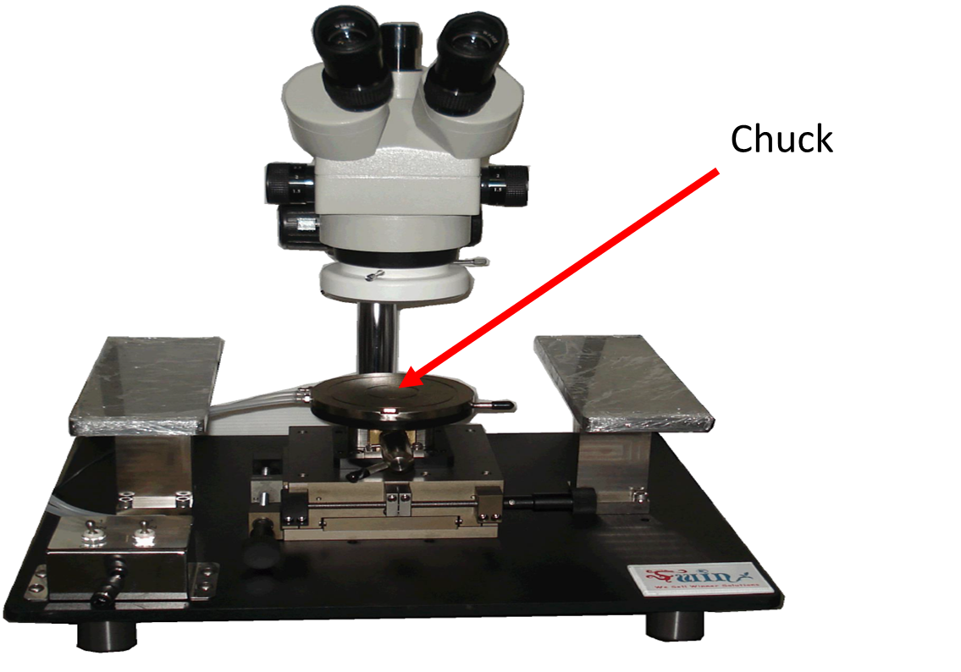

Figure 1: Probe Station